Flight Reservation System
Project: SkyWings | Technology: HTML, CSS, JavaScript (localStorage)

Aim
To create an online flight reservation system with flight search, seat selection and e-ticket generation.

Algorithm
- Start: load flights and bookings from localStorage.
- User logs in; chooses origin, destination, date and passengers.
- Search flights matching the route and display price and timing.
- Generate seat labels (e.g. 1A–10F); disable booked seats.
- User picks seats; compute total fare.
- Confirm booking, save and generate e-ticket.
- Admin adds flights and views reservations. Stop.

Result
The Flight Reservation System was implemented successfully using HTML, CSS and JavaScript. All modules (login, role-based pages, data entry, search/booking and admin management) work correctly in the browser, and data persists using localStorage.

Implementation (Output Screenshots)
Home page
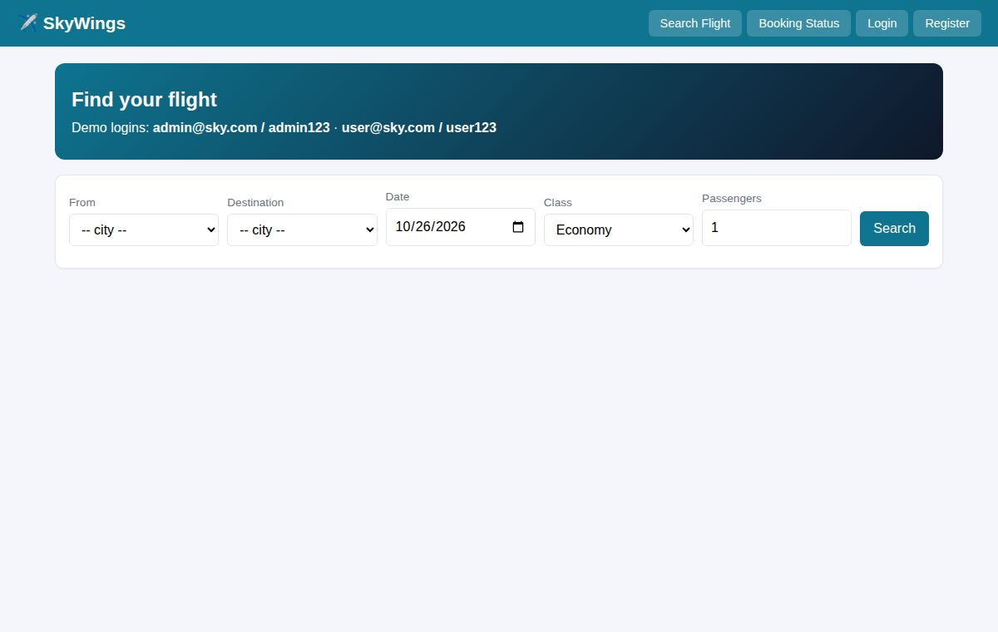
After login (admin / dashboard)
